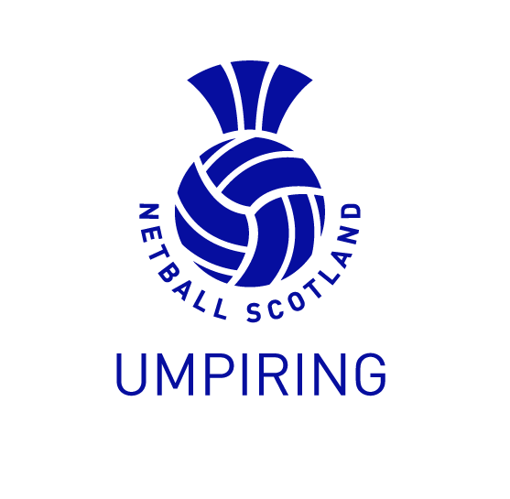
UMPIRE ENDORSEMENT CRITERIA/COMPETENCY SHEET

UMPIRE NAME
LEAGUE
AWARD ENDORSEMENT
MATCH
VENUE
DATE
VISION |  |  | COMPETENT/NOT COMPETENT
POSITIONING |  |  | COMPETENT/NOT COMPETENT
MOVEMENT & TIMING |  |  | COMPETENT/NOT COMPETENT
RULES KNOWLEDGE & APPLICATION |  |  | COMPETENT/NOT COMPETENT
GAME MANAGEMENT |  |  | COMPETENT/NOT COMPETENT
MINOR INFRINGEMENTS |  |  | COMPETENT/NOT COMPETENT
MAJOR INFRINGEMENTS |  |  | COMPETENT/NOT COMPETENT
ADVANTAGE |  |  | COMPETENT/NOT COMPETENT
AREAS OF STRENGTH

AREAS FOR DEVELOPMENT
RECOMMENDATION FOR LICESNING | PASS  NOT COMPETENT |  | Delete as applicable
ASSESSOR NAME & SIGNATURE |  |  | Date:

