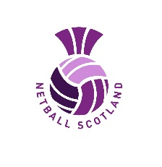

NETBALL SCOTLAND
CONFIRMATION OF FITNESS TEST RESULT
(For learners applying for a Europe Netball Practical Assessment)

- For those B Award umpires who are applying for the A Award Assessment a minimum level of 7.1 will be required
- For those C Award umpires who are applying for the B Award Assessment a minimum level of 6.1 will be required
- Fitness Test must be completed within 6 weeks before the practical assessment

Please complete this form electronically and return to educationadmin@netballscotland.com within 14 days of test result.

Umpire’s details
Name of Umpire
Netball Scotland membership No.
Local Association
Address 1
Address 2
City/Town
Postcode
Telephone number
Mobile Number
Test details and results
Date of Fitness Test
The above named has successfully completed the Multistage Fitness Test and has reached Level:
Location of Fitness Test (This must be an indoor facility)
Print Name
Official Capacity
Personnel identified to act as a recorder for this test must be:
- Sports specific qualified
- Qualified netball coach
- PE Teacher
Dated

This is to certify that I have tested the above umpire, and I can confirm the following:
- Test used was Multi-Stage Fitness Test (Beep/Bleep/20m Shuttle Run Test)
- All specifications for the administration of this test were correctly applied
- The umpire reached the level indicated on the above date
- I am officially accredited to administer this test

If you are unable to scan this form and do not have an electronic signature, placing your name below will be deemed to be certification of the above information.

Signed:

